**12.Raspberry Pi platform -------** **Bluetooth_control**

**1)Introduction of experimental**

In this experiment, we control car by Bluetooth App by Android Mobile phone. The mobile phone sends commands through the serial port to control the advance, backward, turn left, turn right , stop, any angle control of the servo, out fire, whistle, speed of robot car.

At the same time, the status of various sensors on the robot car and the distance measured by the ultrasonic wave are displayed in real time on the Bluetooth APP interface by the serial port.

**2)Experimental Steps**

(1) You need to install the 【Yahboom 4WD Controller】 software on your Android mobile phone, turn on the power switch of the car(the red indicating light of the Bluetooth module is flashing). You should open the Bluetooth on your Android mobile phone and open the 【Yahboom 4WD Controller】 software. Bluetooth is automatically connected when the Mobile phone is near the robot.

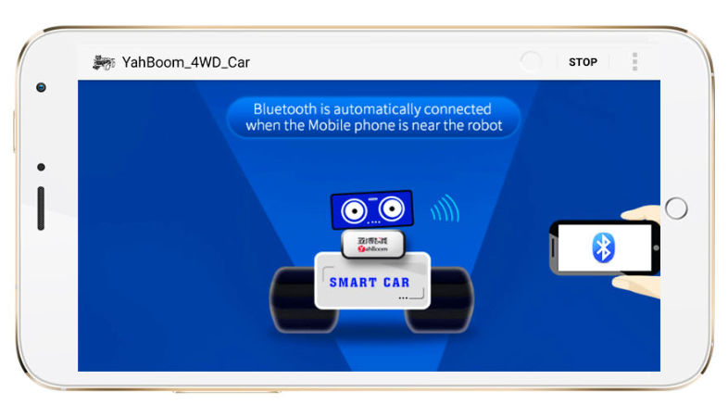

1. After successful connection,enter the main control page

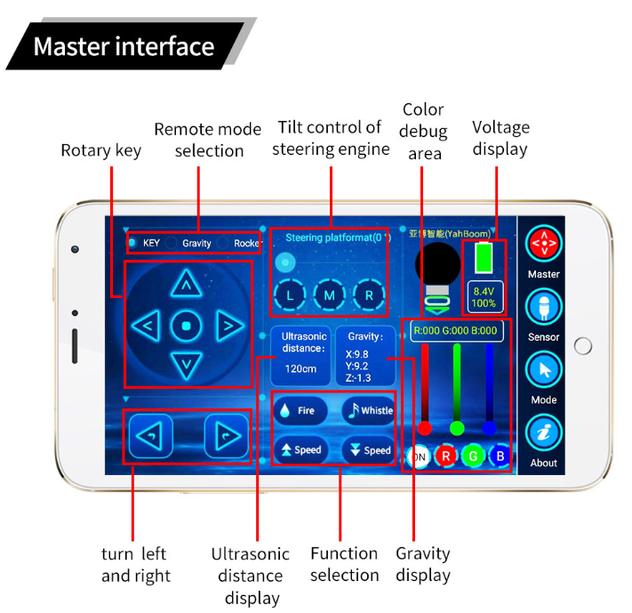

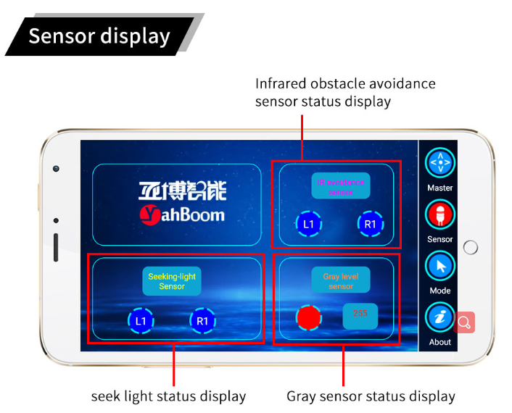

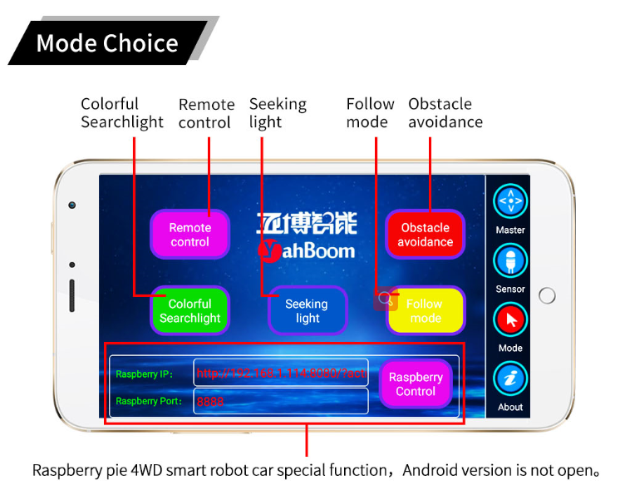

**3) About the code**

1. We need to compile this file in the Raspberry Pi system. (Note: we need to add -lwiringPi and -lpthread to the library file.)

We need to input:gcc bluetooth_control.c -o bluetooth_control -lwiringPi -lpthread

(2)We need to run the compiled executable file in the Raspberry Pi system.We need to input: ./bluetooth_control

(3)We can input: ctrl+c to stop this process, which mean is send a signal to the linux kernel to terminate the current process, but the state of the relevant pin is uncertain at this time, we also need to run a script to initialize all pins.

(Note:The initpin.sh script file is included in the SmartCar directory.)

You need to input:  chmod 777 initpin.sh

./initpin.sh

After completing the above steps, the experiment is over.

!!!Note:

1. The Bluetooth module needs to be properly inserted into the expansion board of the robot car.

2. 51/Arduino Download Switch on the expansion board must be set to [OFF].

3. The ultrasonic module must be inserted.